Feature: Team Inbox
Transform your customer communication with a high-velocity, centralised Team Inbox, now engineered for 40% faster performance to handle massive scale with instant response times. This shared workspace allows multiple team members to access and manage all your business’s WhatsApp conversations from a single, unified dashboard with zero-latency, real-time collaboration.
You can utilize Smart Chat Assignment to route conversations to specialized agents—ensuring team members only see their focused workload—while maintaining full Communication Transparency through "Sent By" tracking to know exactly which agent communicated with which lead. Empower your support, sales, and marketing teams to work together seamlessly, handling high volumes of inquiries without ever missing a beat.
Why Team Inbox Matters:
For businesses that are scaling, a Team Inbox is the key to delivering fast, personal, and organised customer service through WhatsApp. It moves you beyond the limitations of a single-device app and provides a robust, lightweight platform for professional team-based communication.
- Boosts Team Productivity and Collaboration: Enable your team to work together with zero-latency synchronization. By routing chats to specific agents and limiting views to their focused workload, you eliminate confusion and allow for faster resolution times, significantly increasing overall team efficiency.
- Enhances Customer Support: With a unified view and instant interface response times, your team can respond faster than ever. The ability to see conversation history, internal notes, and context means customers don't have to repeat themselves, leading to higher satisfaction and loyalty.
- Streamlines Sales and Lead Management: Your sales team can effectively qualify leads and guide prospects through the purchasing process within the shared inbox. "Sent By" tracking ensures you always know which sales agent is nurturing a lead, creating a more efficient and accountable sales cycle.
- Provides Actionable Insights & Transparency: Beyond built-in analytics, gain granular visibility into your team's operations. Monitor response times and use "Sent By" tracking to audit individual agent contributions, allowing you to optimize your support strategy and make informed decisions to improve customer engagement.

Step by Step introduction
Click on "Team Inbox"
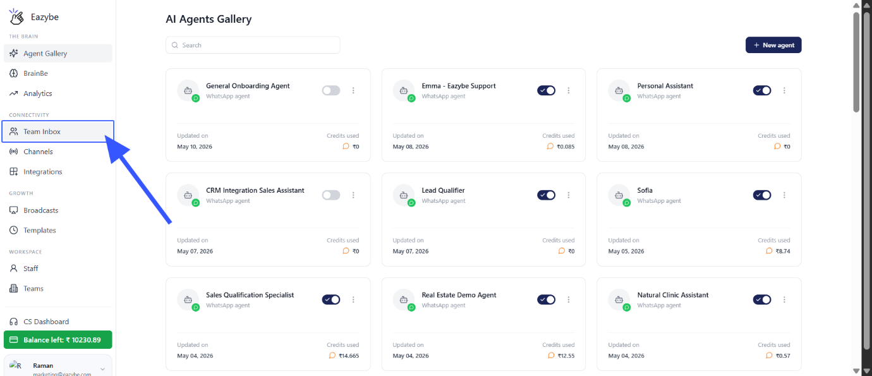
Under the Team Inbox you have chat filters : All, Unreplied, Groups, Broadcast etc.
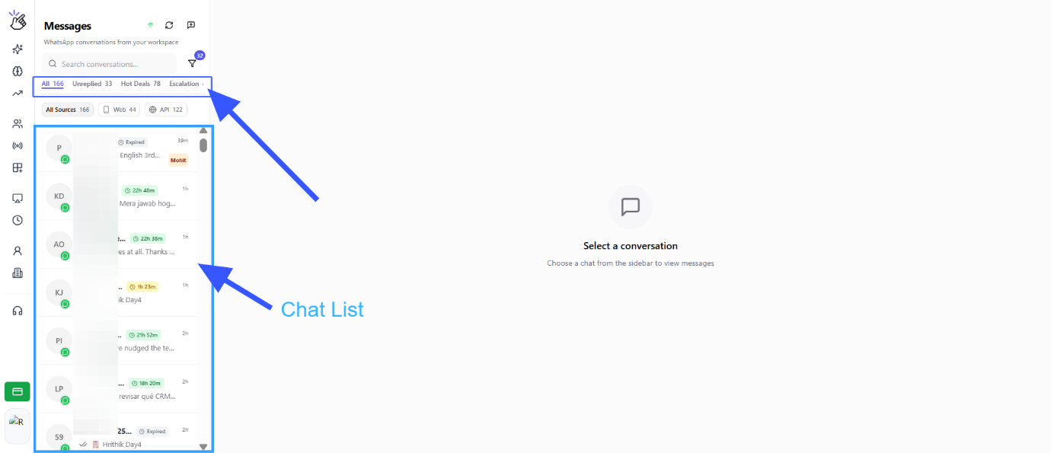
Click on any to view the corresponding chats
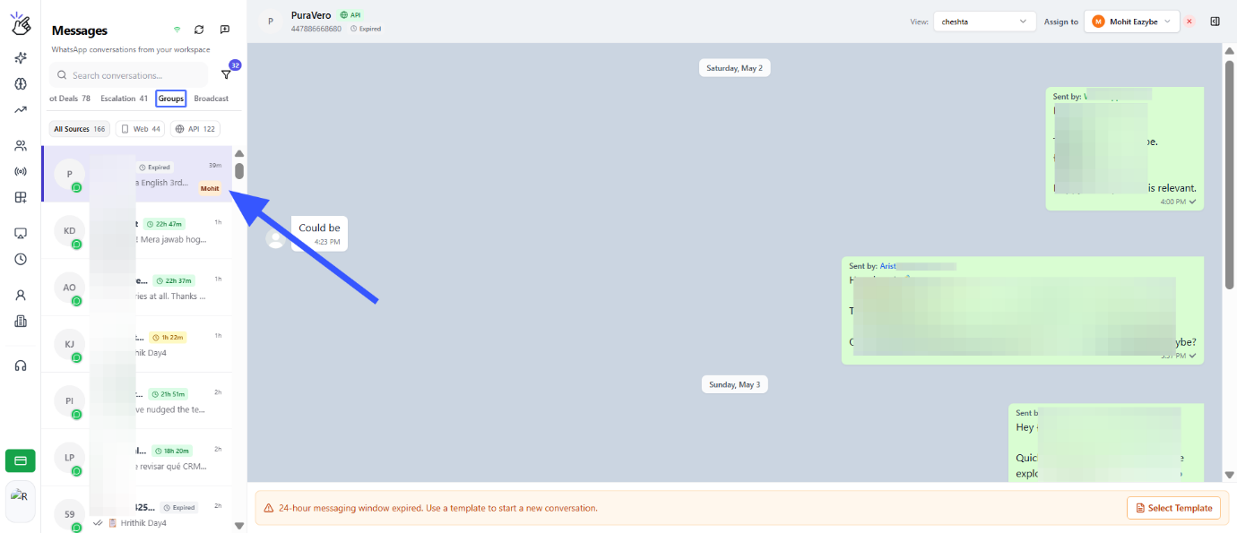
Click on group filter to view group chats
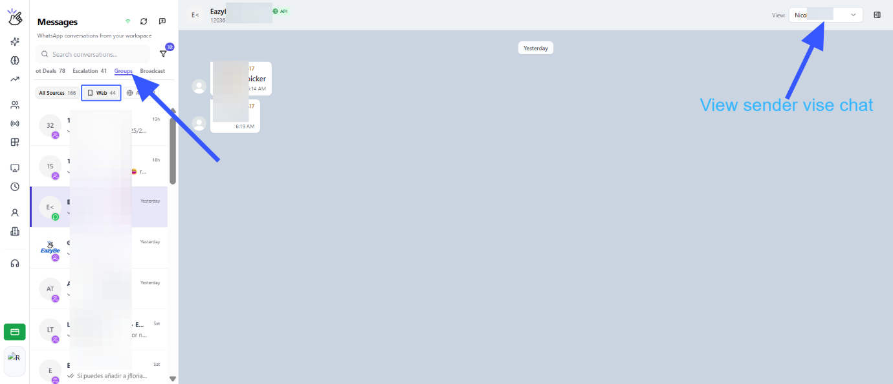
You have different layers of chat list filters where you can choose and view chat list based on the on the normal WhatsApp and WABA API numbers
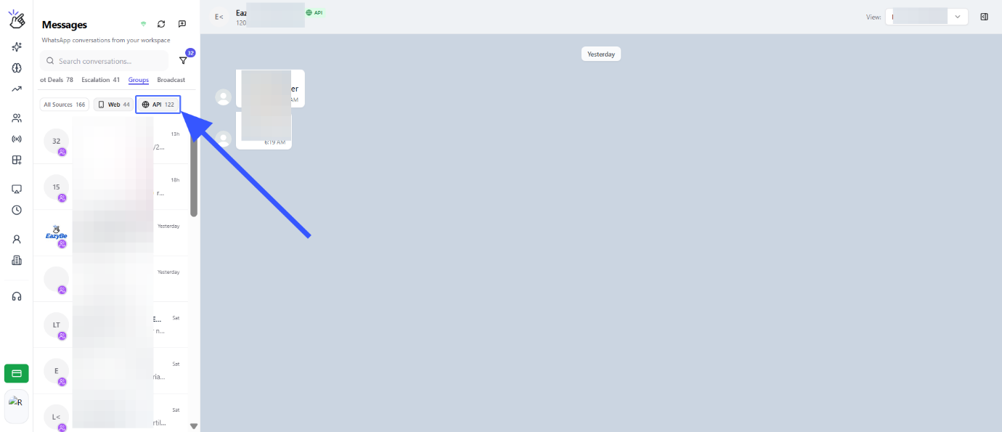
Click on filter , where you can select the numbers of which you want to see the Chat list
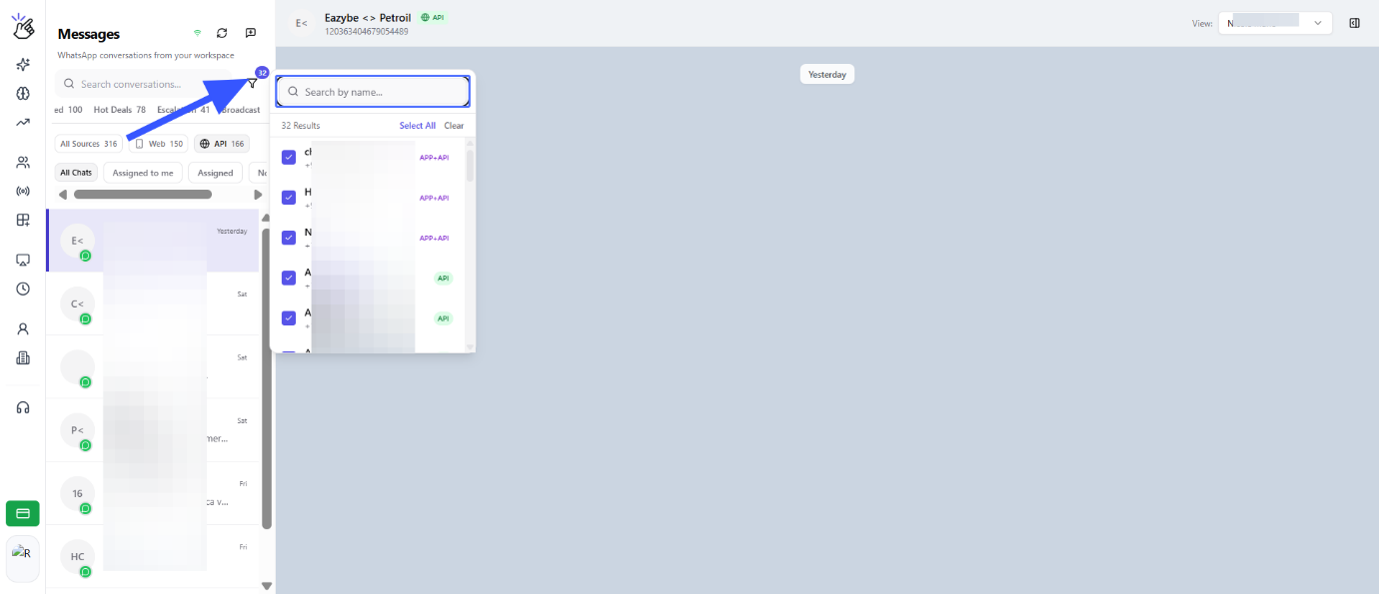
You can search for the chats search bar
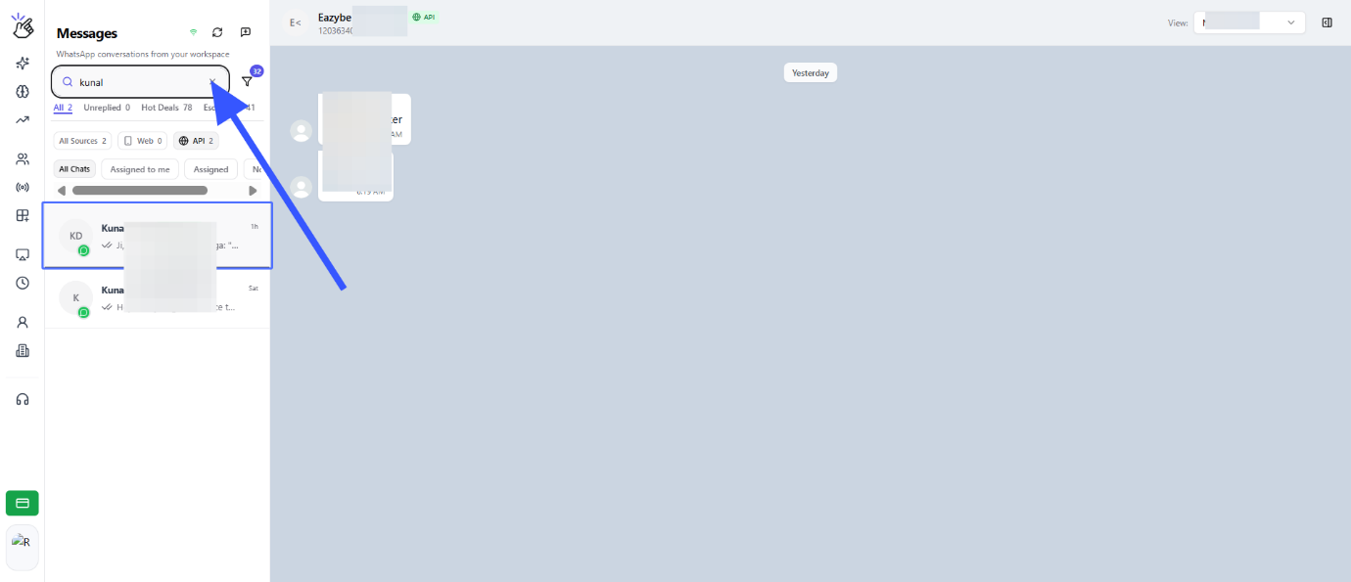
Service window timer for WABA numbers
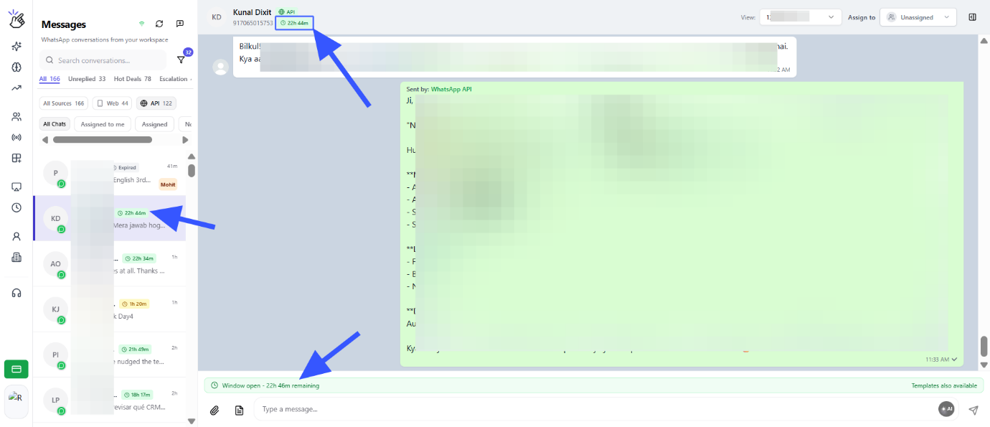
Chat view
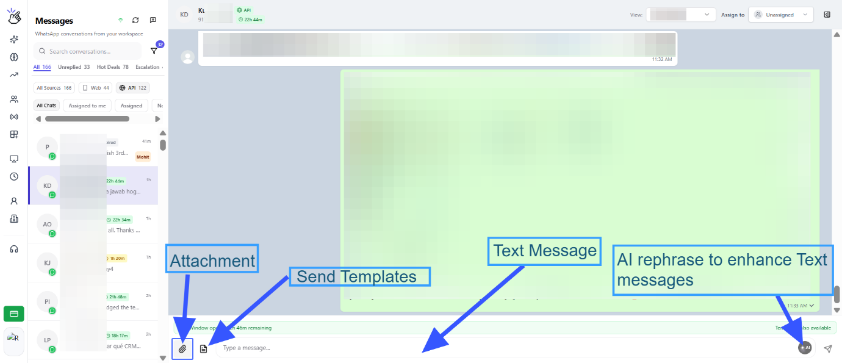
Send template
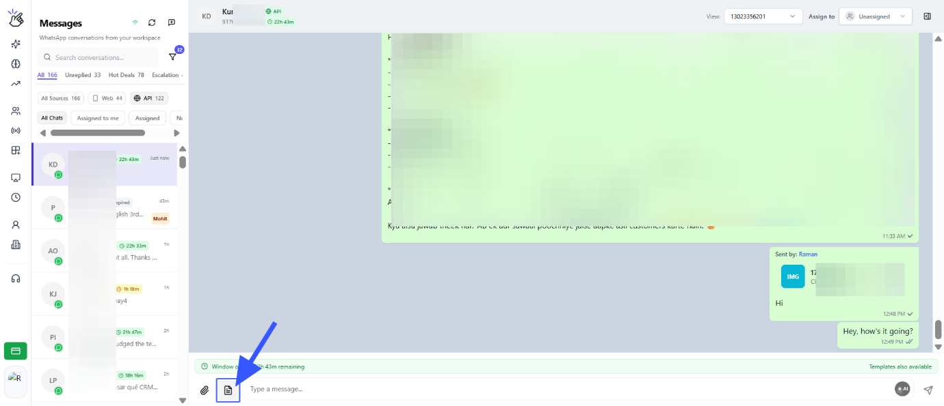
Select template and click on send
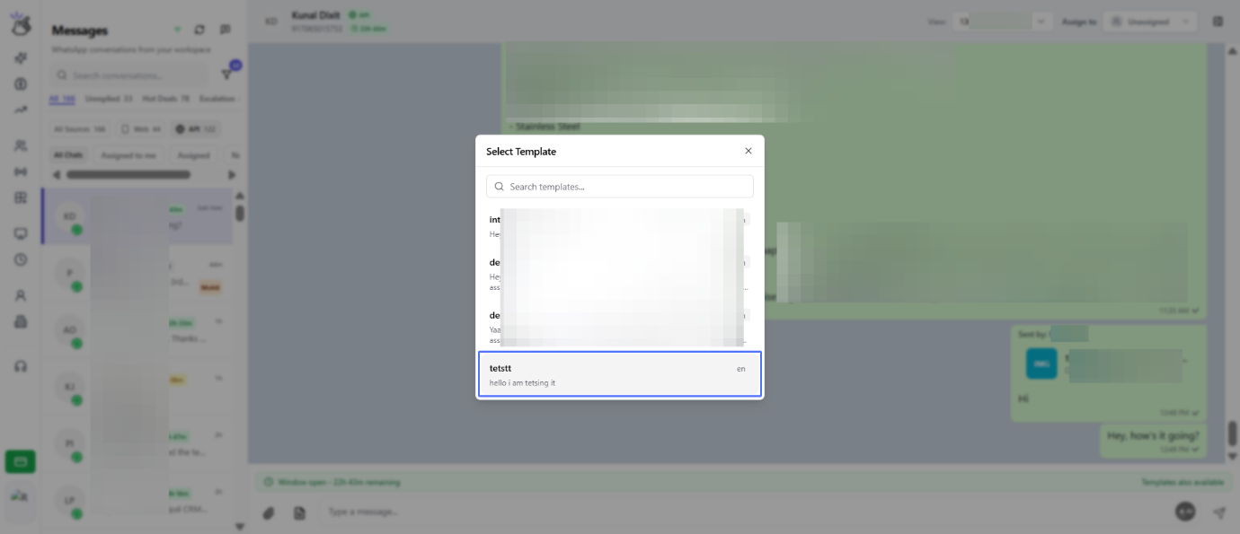
Click on "Start new chat" to message a new contact
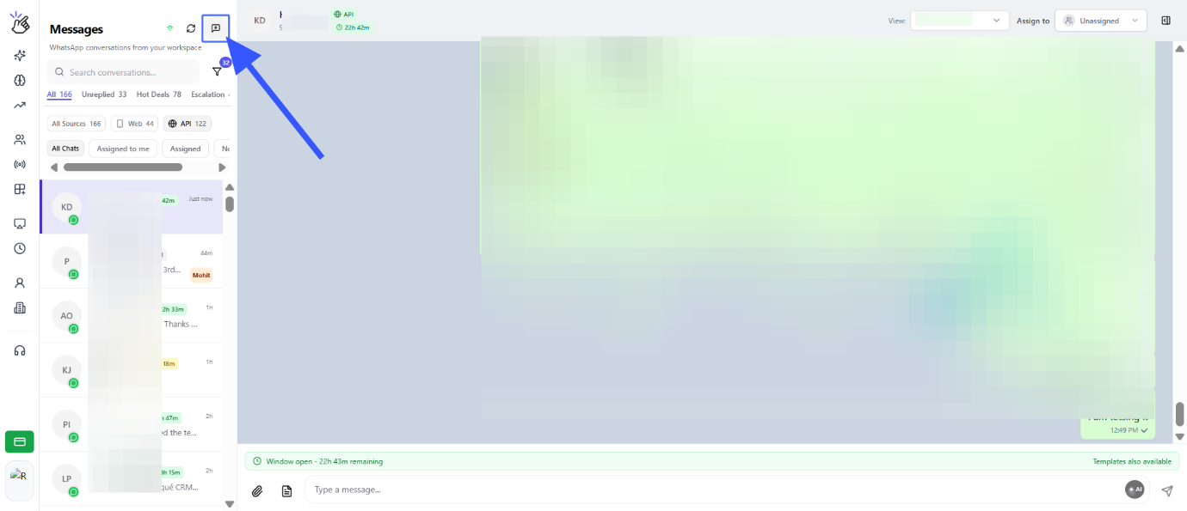
Click on the input
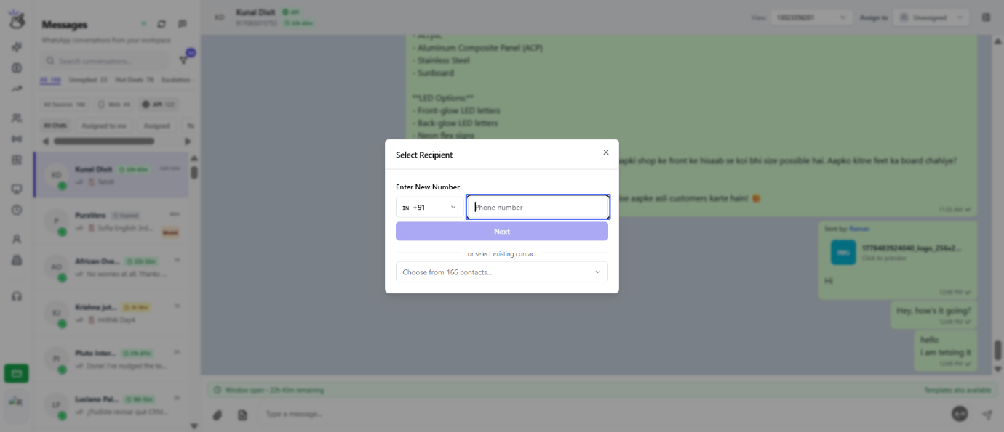
Input the new number with country code and click on next
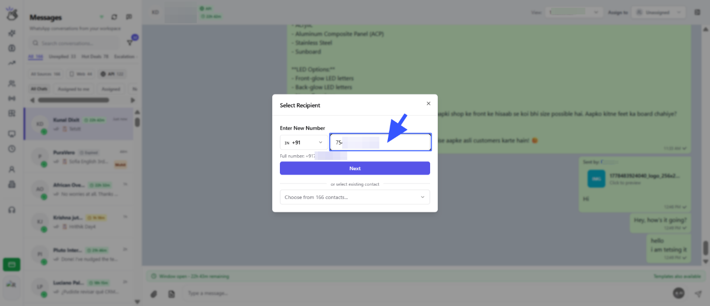
Select the WABA number and Click on the button "Choose Template & Send"
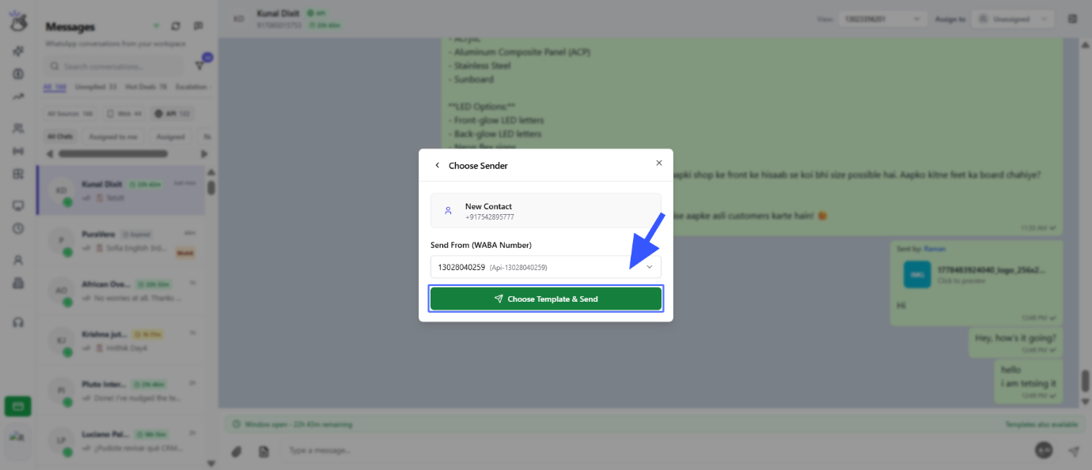
Select the template and click on send
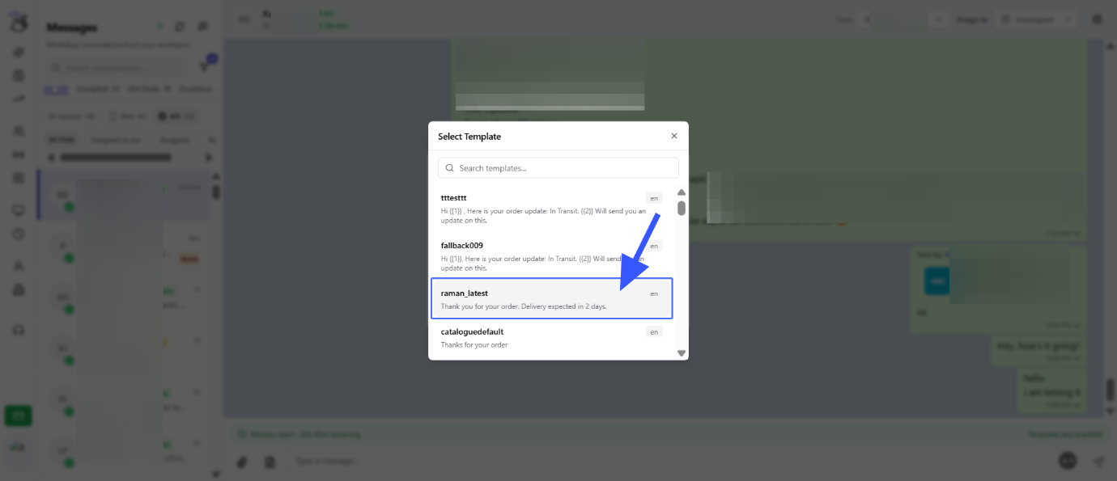
Chat Assignment : Click on the Assign to drop down
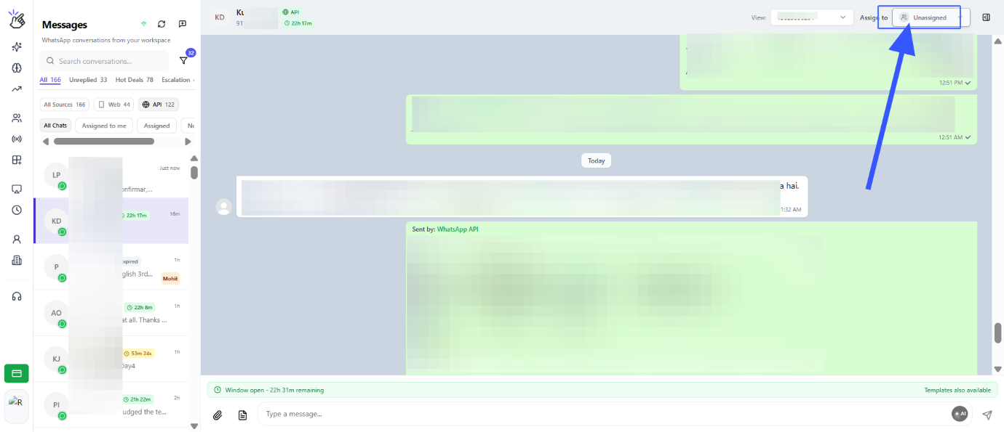
You get a Team wise employees and also All Employees section to assign this chat
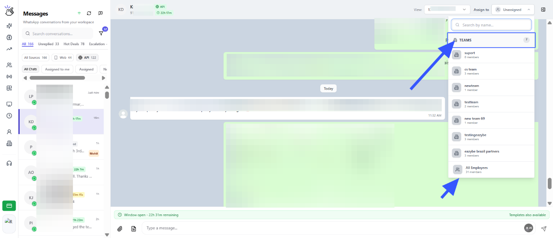
Click on any Team and select whom to assign
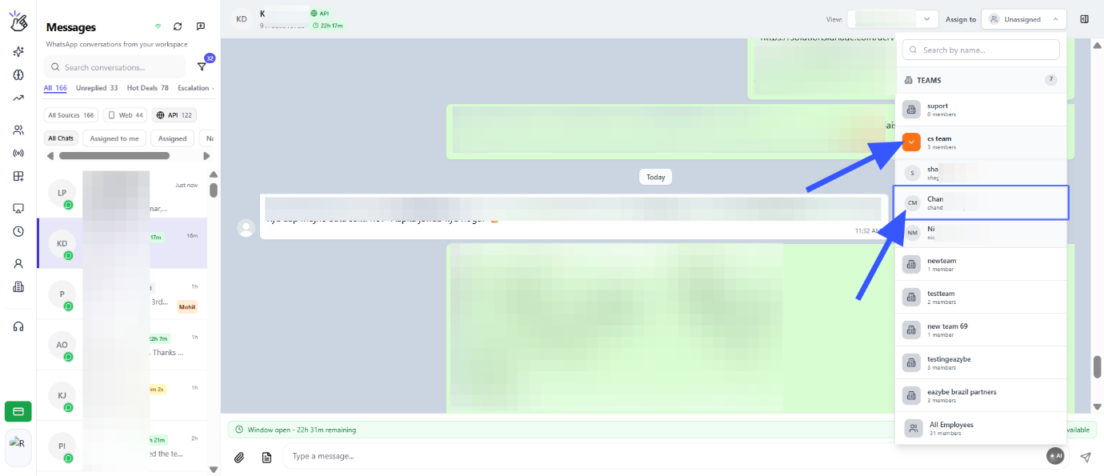
Now the chat have been assigned to the selected Employee and they can access this under their login
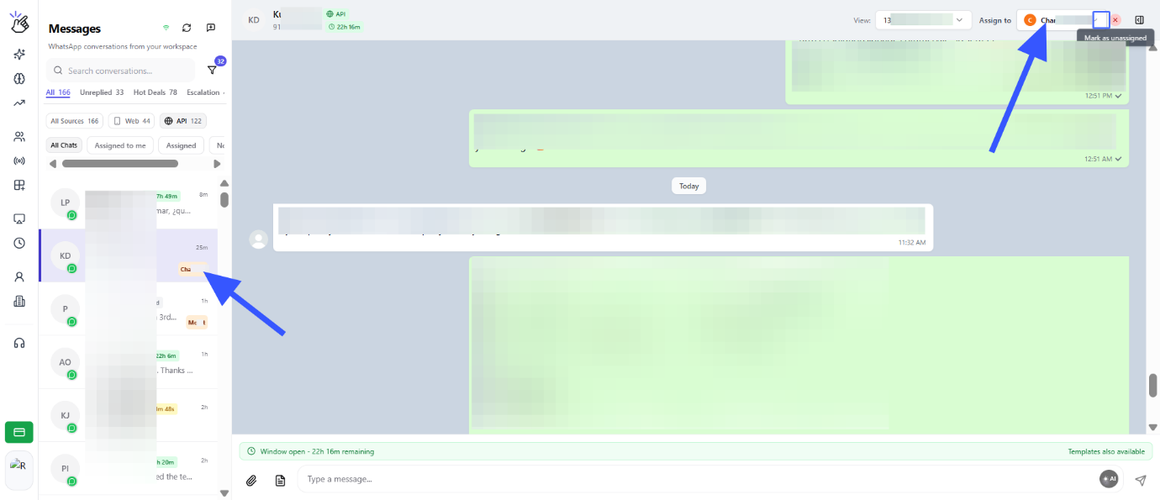
You can also mark the chat as unassigned
